AI based discourse for Banking Industry

**Team ID : PNT2022TMID25247**

**Installing python package**

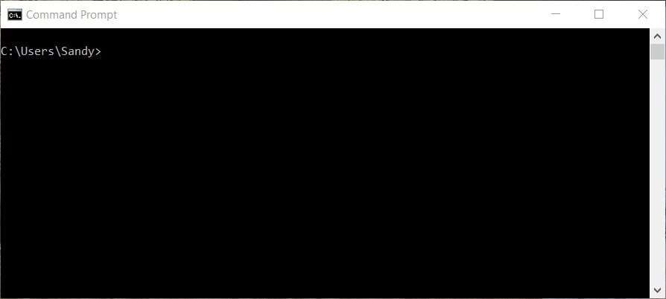**Step 1 :** Open the CMD.exe prompt

**Step 2**: Install the **Flask** package . to enter the **Flask** packageenter the command in the CMD,exe

**Command:** Pip install Flask **Flask :**

